Methods for Designing by Dimension
Generate a realm of ideas!
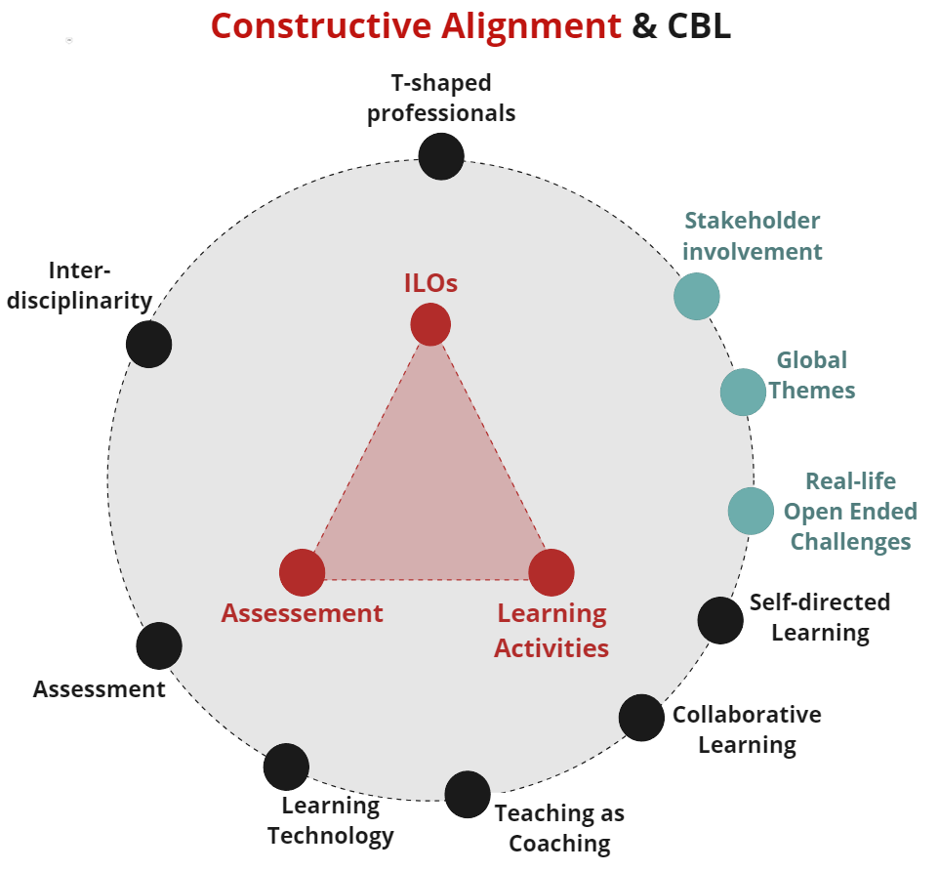
This tool assists you in enriching your course with more brilliant ideas.
This tool is only valuable if you have at least a basic idea of the Constructive Alignment of your course/project:
- you have ILOs;
- you have an idea of the Learning Activities;
- you know how to Asses the learning activites.
As you can see in the picture all ten dimensions can be related to the components of constructive alignment.

Have these design exercises guided by your Teacher Support. They are trained to do this. Always do them with your full design team.

MATERIALS
- For live session: post-its, pens, printouts of worksheets.
- For online session: Miro, charged laptop, internet.

TO DO
- Make a list of maximum 3 CBL dimension you would like to re-design (you can use your answers on the CBL Aspiration Tool).
- Pick the methods you need and find out how much time you need for every method (see top left corner of each method).
- Organize a brainstorm meeting for your team.
- Read the methods instructions and execute them.
- Gather all the output of ideas you’ve created and structure them, combine matching ideas.
- Optional: Do a last idea round based on all the output following design question: How might we combine idea X with idea Y?

Overview of all methods for designing by dimension

- T shaped professionals
- Self-directed Learning
- Collaborative Learning
- Learning Technology
- Interdisciplinarity
- Teaching as Coaching
- Stakeholder Involvement
- Global Themes
- Real-life Open Ended Challenges
